DEPARTMENT : Investment Operations
PROCESS NAME : Treasury Hub & Derivatives Operations
DATE: 11.15.2025

DESCRIPTION: | Ensure that the systems normally used are available and operational
STEPS | OUTCOME | COMMENTS (INCLUDING TIME)
Access systems:  Swift Interface Monitor- BSI  T24  MS Office  DTCC – BSI | Ran Incoming MT300 report for Data Validation – Matched report from 11.14.25  Ran FX S report for Data Validation – Matched report from 11.14.25  Received e-mails and opened a report saved in Excel  Access Denied | Login at 10:28 AM  Login at 10:36 AM  Login 10:28 AM  Platform not available on Saturdays

Data Integrity Validation Testing
Execute the data integrity validation procedure and provided evidence of the results
Application In-scope: T24 & Swift Interface – BSI
Data Domain Integrity | Yes/No | Comments
Was the type, format, data length accurate for each field reviewed?  Examples:  - Dollar amount in balance field, correct number of positions, etc.  - Name in name field, last name and first name in correct spots  If any data was inaccurate, corrupt, or misplaced, please specify | Yes | Data matched on reports run at end of day on 11.14.2025 and on the morning of 11.15.2025. All columns, number of records, field names, were the same.
Data Entity Integrity
Were the data headers correct and were there no unexpected blanks or duplicate records?  If any data headers were incorrect or if there were unexpected duplicates or blanks, please specify | Yes | Data headers were the same on the reports run on both days.
Do the values in the data fields match the data history source in terms of content and volume?  Data comparison validates recovered data matches source history data.  If there are any mismatches or inconsistencies, please specify | Yes | The values in the data fields matched both reports.

PRINT NAME OF OPERATOR

Michelle Oropesa

Below please add screenshots of evidence for each test performed

Data Validation: Incoming MT300s on 11.14.2025

11.14.2025

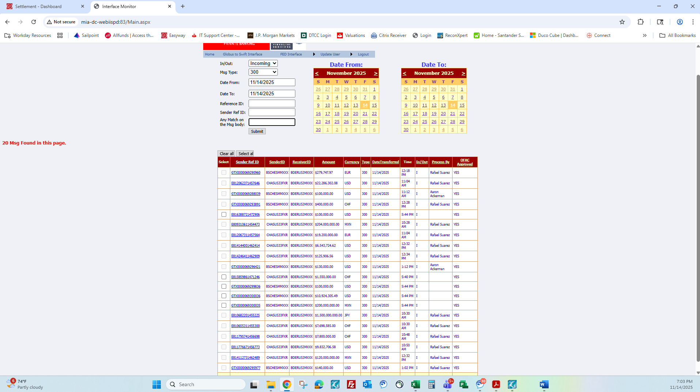

11.15.2025

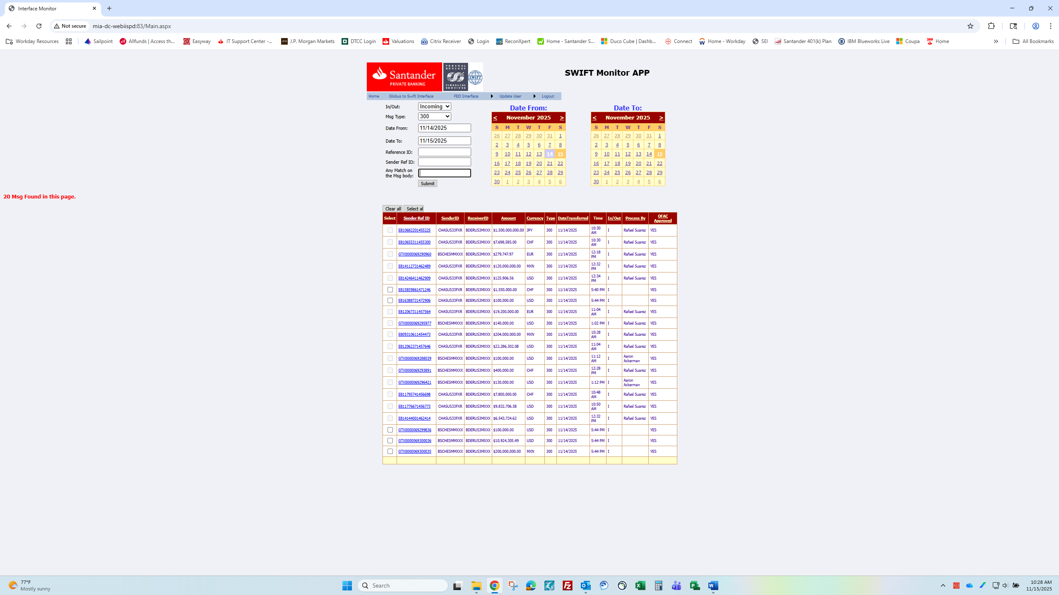

Data Validation: FX S report for trades done on 11.14.2025

11.14.2025

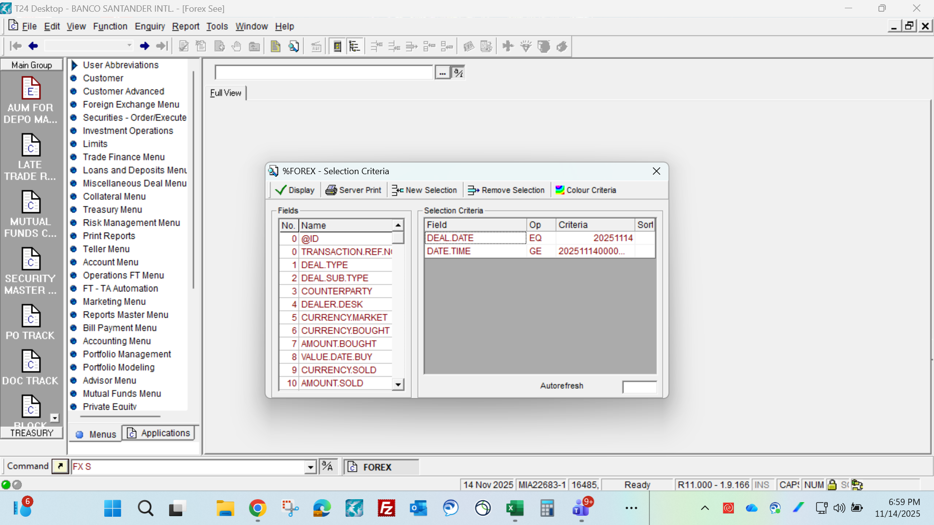

11.15.2025

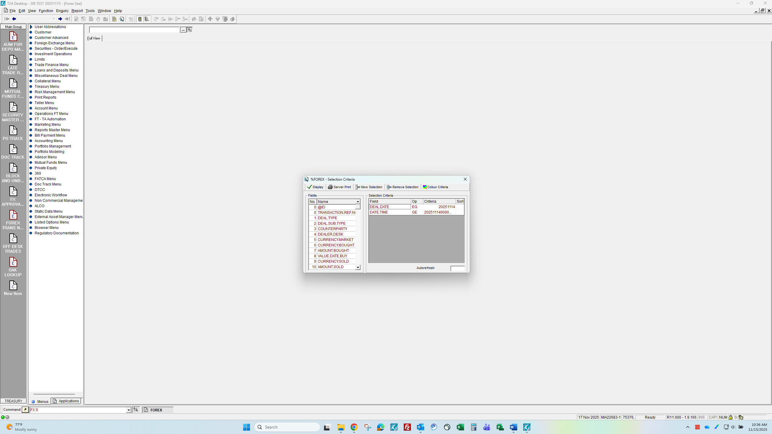

MS Office

Outlook
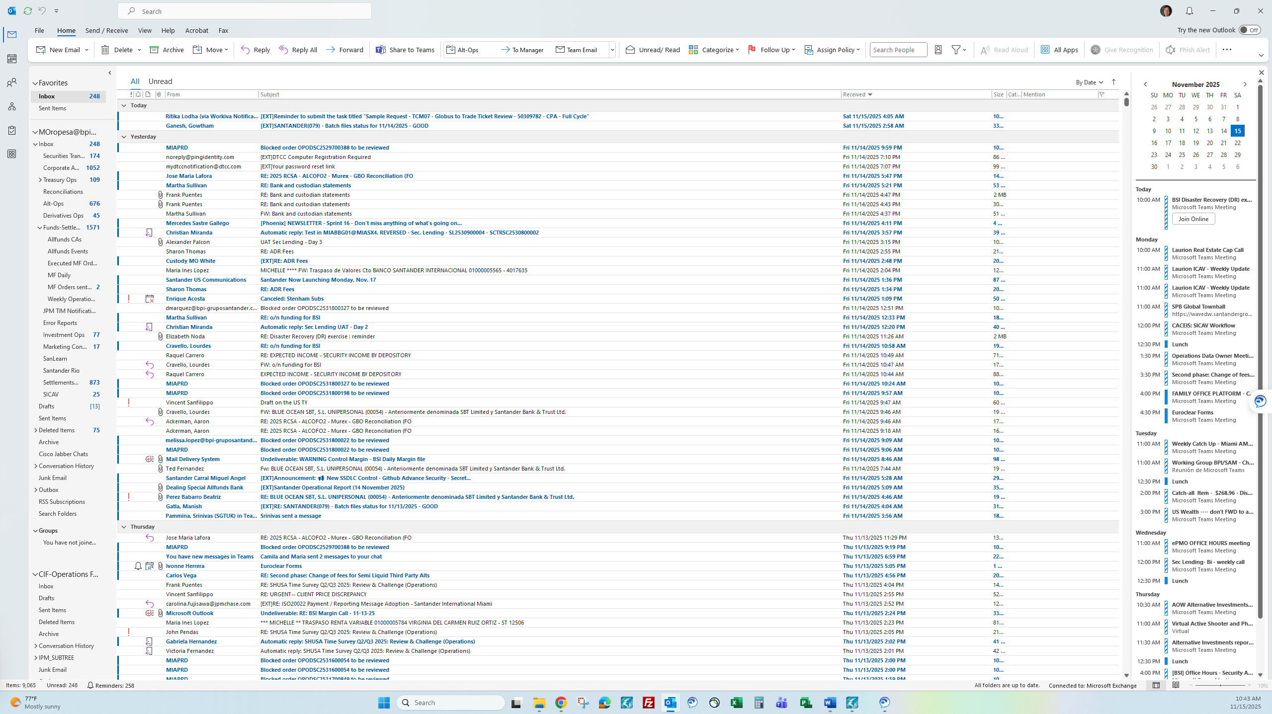

Excel
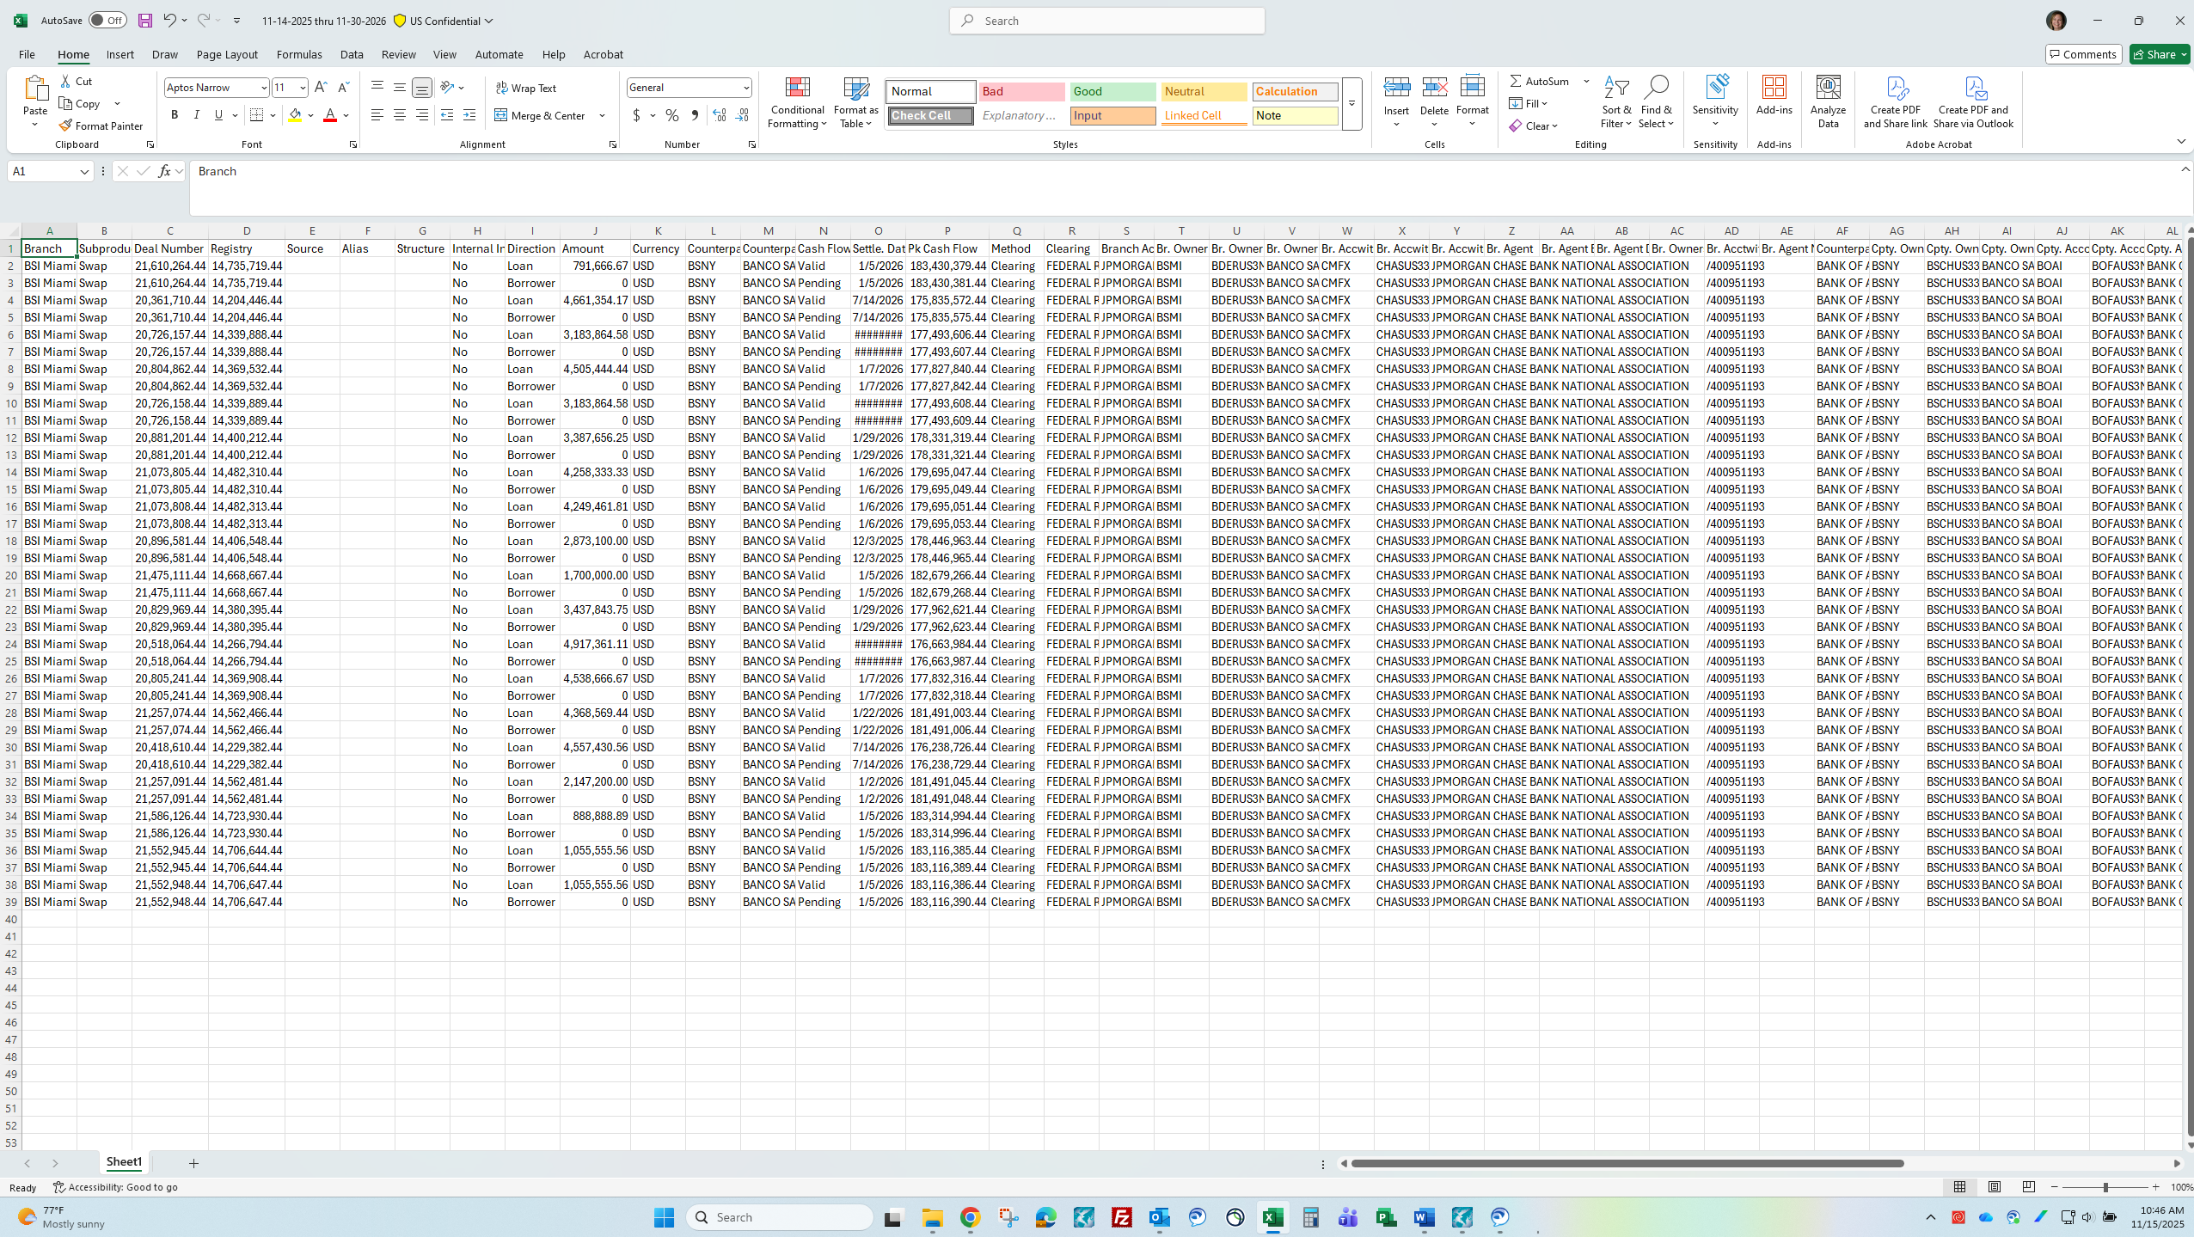

DTCC Platform is unavailable on Saturdays:

Screenshot below for confirmation

